Homeowners –
We are writing to notify you of a very important issue and upcoming meeting.
Dowell Farms Detention Pond
The fence surrounding the detention pond at the corner of the Trace and the Trail is in immediate need of repair/replacement. As per Cobb County Code 50-112, it is the responsibility of the HOA to maintain the pond and fencing. The fence is now 10+ years old and is in disrepair and falling in areas. The wooden fence is in a state that prevents it from being repaired. The HOA Board has received several quotes from reputable fencing companies for the cost of replacing the current fence with a chain link fence. A chain link fence will last longer than a wooden fence. The quotes we have received are all at a cost of ~$15,000.
The current budget allocation allows the HOA Board to pay half of the fence from the current reserve funds. The remaining cost will require the HOA Board to levy a special assessment on each homeowner that is estimated to be $234 per home. The HOA Board is asking you all to join us for a meeting on June 11th at 3:00 PM in the cul-de-sac next to the detention pond to discuss the issue and have a Q&A session. Below is a copy of the budget to date, including expected repairs for the future.
We look forward to seeing you all on Sunday, June 11th at 3:00 PM. For your comfort, please bring a chair.
Thank you,
Dowell Farms HOA Board

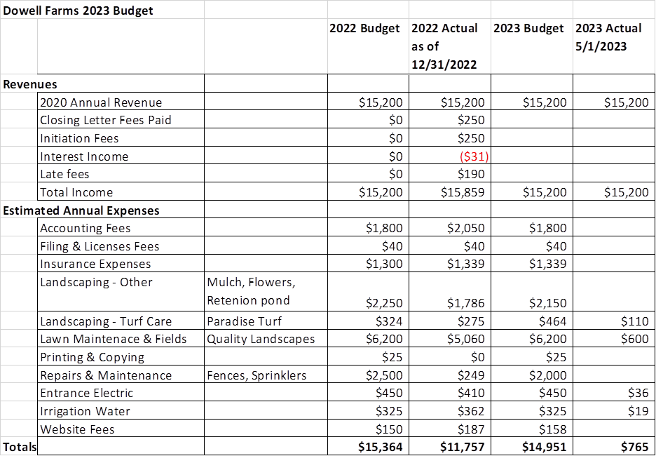

Expected Repairs/Replacements
Line Item | Total Estimated Repair/Replacement Cost | Annual Allocation (expected repair/replacement per year cost total allocated over 10 years) | Reserve Allocation Balance as of 5/31/2023
Detention Pond Fencing | $12,000 - $15,000 | $1,200 - $1,500 | $7,512
Detention Pond Retaining Wall | $4,000 - $10,000 | $400- $1,000 | $4,000
Shrubs in upper open space | $1,400 – 2,800 | $140 - $280 | $700
West Sandtown Road Fence | $6,000 | $600 | $5,800
Amount to be added to reserve fund annually |  | $2,340 - $3,300
Required Reserve for All Repairs | $23,000 - $33,800 |  | $18,012
Current Reserve Balance | $18,071 |  | $18,071
Balance in Reserve | ($4,929 - $15,729) |  | $59

